BUSINESS QUESTIONS AND VISUALISATION REPORT
Team ID | MCA
Project Title | Smartphone Addiction & Digital Well-Being Insights
Maximum Marks | 5 Mark

1. Introduction
This report presents business questions derived from the supplied Power BI dashboard on smartphone usage and addiction. Each question is presented separately, followed by the relevant dashboard screenshot and a brief observation. The format is designed for clear academic presentation without using a table.

2. Business Questions and Visualisations
1. What is the average daily screen time by gender?
Visualization: Average Daily Screen Time by Gender
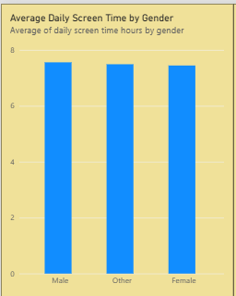
Figure 1. Average daily screen time by gender.
Observation: The dashboard shows very similar average daily screen times for Male, Other and Female users. All three bars are in the 7 to 8 hour range, indicating only small visible differences between the displayed gender groups.
2. Which addiction level contains the largest number of users?
Visualization: Users by Addiction Level
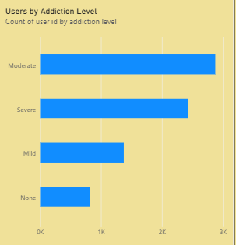
Figure 2. Users grouped by addiction level.
Observation: Moderate is the largest displayed addiction category, followed by Severe, Mild and None. This indicates that the Moderate category represents the biggest group in the dashboard.
3. What percentage of users are classified as addicted and non-addicted?
Visualization: Addicted vs Non-Addicted Users
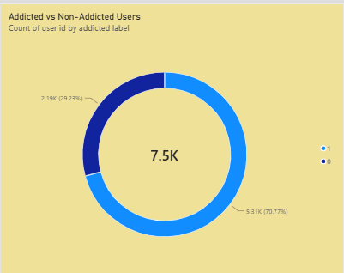
Figure 3. Addicted versus non-addicted users.
Observation: The dashboard contains approximately 7.5K users. About 2.19K users, or 29.23%, are classified as addicted, while approximately 5.31K users, or 70.77%, are classified as non-addicted.
4. How does average daily screen time vary across age groups?
Visualization: Average Daily Screen Time by Age Group
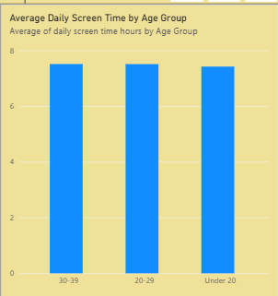
Figure 4. Average daily screen time by age group.
Observation: The 30–39, 20–29 and Under 20 groups show very similar average daily screen times, each close to about 7.4 to 7.5 hours per day.
5. Is there a visible relationship between daily screen time and sleep hours?
Visualization: Daily Screen Time vs Sleep Hours
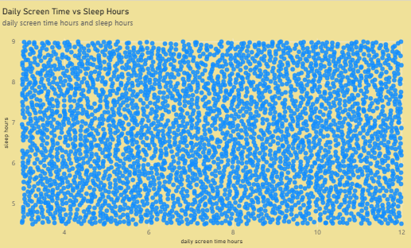
Figure 5. Daily screen time compared with sleep hours.
Observation: The scatter plot contains many observations across roughly 3.5 to 12 hours of daily screen time and about 4.5 to 9 hours of sleep. The visual alone does not show a strong simple linear pattern; a correlation calculation would be needed for a statistical conclusion.
6. How does average social-media usage compare with average gaming usage?
Visualization: Average Gaming vs Social Media Usage
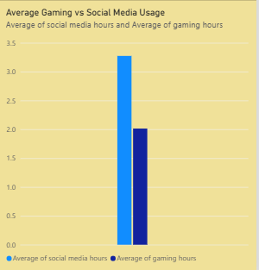
Figure 6. Average social-media usage compared with gaming usage.
Observation: Average social-media usage is approximately 3.3 hours, while average gaming usage is approximately 2.0 hours. The chart therefore shows higher average social-media usage than gaming usage.
7. Are the gender groups substantially different in average screen time?
Visualization: Average Daily Screen Time by Gender
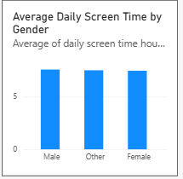
Figure 7. Comparison of screen-time averages across gender groups.
Observation: The bars are closely aligned, so the dashboard does not show a large visible difference in average screen time among Male, Other and Female users.
8. Are the age groups substantially different in average screen time?
Visualization: Average Daily Screen Time by Age Group
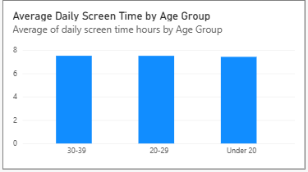
Figure 8. Comparison of screen-time averages across age groups.
Observation: The bars for 30–39, 20–29 and Under 20 are nearly the same height. The dashboard therefore shows only a small visible difference in average screen time among these age groups.

